Applecross Senior High School
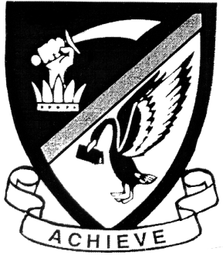
Western Australian Certificate of Education
Semester One Examination, 2018

Question/Answer Booklet
MATHEMATICS

____
97
SPECIALIST
UNIT 1

Section Two:
Calculator- assumed Score for this booklet

Student’s Name: _______________________________________
As shown on your exam timetable.

Student’s Teacher Mrs Waddell

Time allowed for this section
Reading time before commencing work: ten minutes
Working time for this section: one hundred minutes

Materials required/recommended for this section
To be provided by the supervisor
This question /Answer Booklet
Formula Sheet (retained from Section One)

To be provided by the candidate
Standard Items: pens (blue/black preferred), pencils (including coloured), sharpener,
correction fluid/tape, eraser, ruler, highlighters.
Special items: drawing instruments, templates, notes on two unfolded sheets of A4 paper,
and up to three calculators approved for use in the WACE examinations.

Important note to candidates
No other items may be taken into the examination room. It is your responsibility to ensure
that you do not have any unauthorized notes or other items of a non-personal nature in the
examination room. If you have any unauthorized material with you, hand it to the supervisor
before reading any further.

Section | Number of questions available | Number of questions to be answered |  | Working time (minutes) | Marks available | Percentage of exam
Section One:  Calculator-free | 8 | 8 |  | 50 | 53 | 35
Section Two:  Calculator-assumed | 13 | 13 |  | 100 | 97 | 65
 |  |  | Total |  | 150 | 100

Instructions to candidates

- The rules for the conduct of examinations are detailed in the School Examination Rules provided with your exam timetable. Sitting this examination implies that you agree to abide by these rules.

- Write your answers in this Question/Answer Booklet.

- You must be careful to confine your responses to the specific questions asked and to follow any instructions that are specific to a particular question.

- Spare pages are included at the end of this booklet. They can be used for planning your responses and/or as additional space if required to continue an answer.
- Planning: If you use the spare pages for planning, indicate this clearly at the top of the page.
- Continuing an answer: If you need to use the space to continue an answer, indicate in the original answer space where the answer is continued, i.e. give the page number. Fill in the number of the question(s) that you are continuing to answer at the top of the page.

- Show all your working clearly. Your working should be in sufficient detail to allow your answers to be checked readily and for marks to be awarded for reasoning. Incorrect answers given without supporting reasoning cannot be allocated any marks. For any question or part question worth more than two marks, valid working or justification is required to receive full marks. If you repeat an answer to any question, ensure that you cancel the answer you do not wish to have marked.

- It is recommended that you do not use pencil, except in diagrams.

- The formula sheet and your notes are not to be handed in with your Question/Answer Booklet.

Section Two: Calculator-assumed 65% (97 Marks)
This section has thirteen (13) questions. Answer all questions. Write your answers in the spaces provided.

Working time: 100 minutes.

Question 9 (7 marks)
(a) A body travels with a velocity $12i-5j$ ms⁻¹. Determine its speed and the bearing on which it is moving, assuming the positive $y$-axis to be due north. (3 marks)

(b) Given that $λ\left(5i-2j\right)+μ\left(-7i+4j\right)=25i-13j$, determine the values of $λ$ and $μ$.
(4 marks)

Question 10 (7 marks)

(a) Using the digits 0 to 9 inclusive, how many different five digit numbers can be made
if repetition of digits is allowed (1 mark)

(b) A number is divisible by four if the last two digits of the number is divisible by four. For example,
4564 is divisible by four because the last two digits “64” is divisible by four; but 4502 is not divisible by four because the last two digits “02” is not divisible by four. Again, using the digits 0 to 9 inclusive, find how many five digit numbers divisible by four can be formed

(i) if digits may be repeated (3 marks)

(ii) if no digit is to be repeated (3 marks)

Question 11 (8 marks)
Two forces, $F_{1}=230 \text{N}$ and $F_{2}=272 \text{N}$, act on a body at $O$, and make angles of $α=15°,$ and $β=20°$ respectively with the vertical $OP$, as shown in the diagram below.

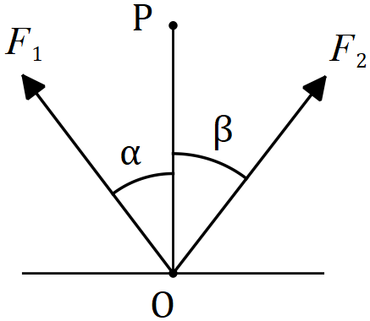

(a) Determine the magnitude of the resultant force and the angle it makes with the vertical.
(5 marks)

(b) The magnitude of $F_{2}$ is to be adjusted so that the direction of the resultant is vertical. Determine the required magnitude of $F_{2}$. (3 marks)

Question 12 (6 marks)
(a) Ten points are equally spaced around the circumference of a circle.
Determine the number of simple (non-self-intersecting) convex polygons that can be formed
by joining either three, four or five of these points with straight line segments
(as in the examples below). (2 marks)

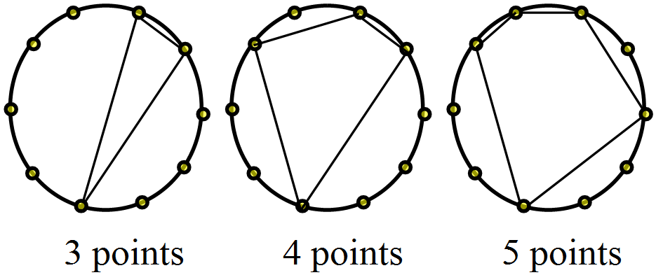

(b) A small coach has 24 seats, arranged in six rows of four seats each, with two seats in each row on either side of the central aisle. A group of passengers consisting of ten males and nine females board the bus.

(i) Determine how many combinations of empty seats are possible once everyone has sat down. (1 mark)

(ii) How many fewer combinations are there if the females all sit on one side of the aisle and the males all sit on the other side? (3 marks)

Question 13 (8 marks)
Consider the three points: A(-5,3), B(6,0) and C(0,-5).
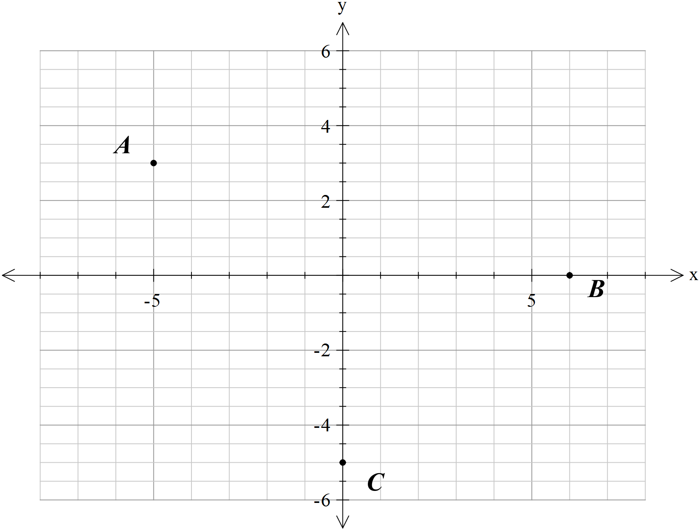
- Determine in terms of the horizontal and vertical unit vectors respectively. (1 mark)

Let K and L be the mid-points of AB and BC respectively.

(b) Without assuming any triangle properties, determine in terms of . (3 marks)

The point B is now allowed to move freely along the axis, so has co-ordinates . Show that p and q are always parallel and that (4 marks)

Question 14 (8 marks)
(a) Simplify $\left(4a-2b\right)∙(a-3b)$ given that $\left|a\right|=5, \left|b\right|=3$ and vector $a$ is parallel and in the opposite direction to vector $b$. (4 marks)

(b) Using $\vec{OA}=a$ and $\vec{OC}=c$, demonstrate a vector method to show that if the diagonals $\vec{OB}$ and $\vec{AC}$ of parallelogram $OABC$ are perpendicular, then the parallelogram is a rhombus.
(4 marks)

Question 15 (9 marks)
(a) In the diagram below, $PA$ and $PC$ are tangents to the circle, with $PA=58$ cm. Secant $PB$ cuts the circle at $D$, so that $PD=40$ cm. Determine the lengths of $PC$ and $BD$. (4 marks)

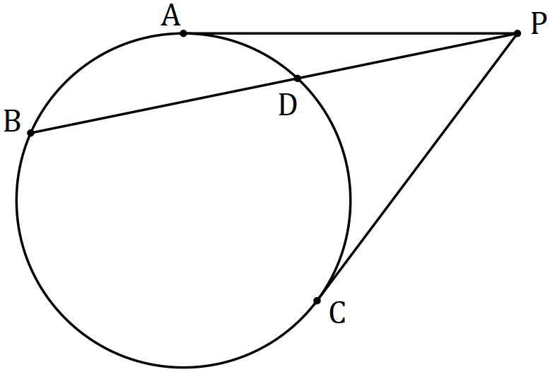

(b) In the diagram below, $A, B$ and $C$ lie on the circumference of the circle with centre $O$, with $AC$ intersecting $OB$ at $D$. Prove that $∠DAO=∠DBC-∠DCB$. (5 marks)

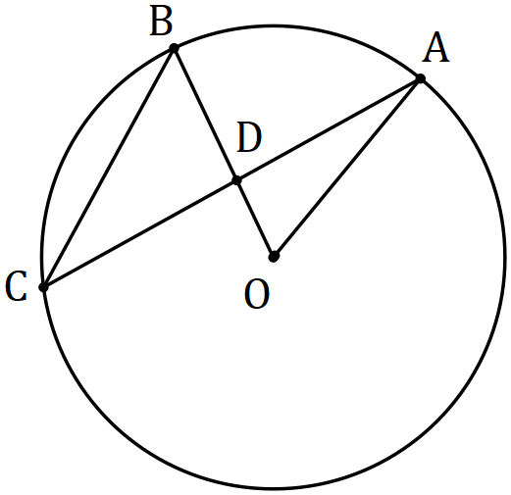

Question 16 (9 marks)
(a) Determine the number of integers between $1$ and $370$ that are divisible by $4$ or $7$.
(4 marks)

(b) A pigeon fancier has $5$ Florentine, $6$ King and $8$ Maltese pigeons and must choose three of them to enter in a local show. Determine the number of different ways the three pigeons can be chosen if

(i) there are no restrictions. (1 mark)

(ii) the fancier decides to take one of each breed. (2 marks)

(iii) the fancier decides to take at least two Maltese pigeons. (2 marks)

Question 17 (6 marks)
Three vectors are $u=ai+bj, v=-3i+5j$ and $w=-i+4j$.

(a) Determine the vector projection of $v$ on $w$ in exact form. (2 marks)

(b) If $u$ has the same magnitude as $v$ and is perpendicular to $w$, determine the exact values of the coefficients $a$ and $b$. (4 marks)

Question 18 (7 marks)
(a) In the diagram below, points $B$ and $C$ lie on the minor arc $AD$ of the circle with centre $O$. The lengths of chords $AB$ and $CD$ are congruent, $∠BOC=37°$ and $∠AOD=163°$. Determine the size of $∠CBD$. (3 marks)

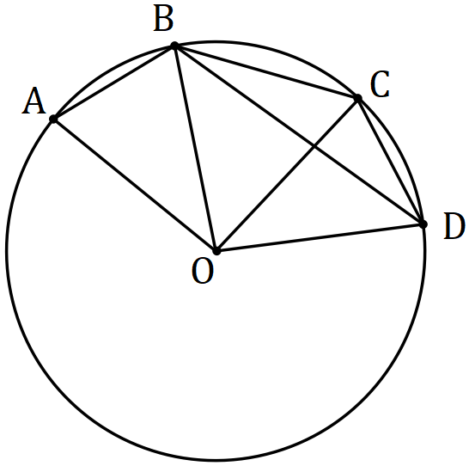

(b) Line segment $AC$ intersects line segment $BD$ at $N$. Given that $AC$ and $BD$ are non-parallel and the lengths $AN, AC, BN$ and $BD$ are 6, 41, 21 and 31 cm respectively, explain whether the points $A, B, C$ and $D$ are concyclic. (4 marks)

Question 19 (8 marks)
(a) Triangle $ABC$ has vertices with position vectors $A\left(2, -6\right), B(-3, 14)$ and $C(6, 8)$. Point $P$ lies on side $BC$ so that $2\vec{BP}=\vec{PC}$. Determine the vector $\vec{AP}$. (4 marks)

(b) $OPQR$ is a parallelogram. Point $M$ is the midpoint of side $PQ$ and point $N$ is on side $QR$ so that $QN=\frac{3}{5}QR$. If $\vec{OP}=p$ and $\vec{OR}=r$, determine $\vec{MN}$ in terms of $p$ and $r$. (4 marks)

Question 20 (7 marks)
A small boat leaves jetty $A$ to travel to jetty $B$, $276$ m away on a bearing of $240°$. A steady current of $2.5$ ms⁻¹ runs in the river between the jetties on a bearing $130°$. If the small boat travels at a constant speed of $6.5$ ms⁻¹, determine the bearing it should steer to reach jetty $B$ and how long the journey will take.

Question 21 (7 marks)
A child is playing with thirteen coloured cubes, all the same size. There are six pink cubes, three navy and one each of red, blue, orange and green.

(a) If the child stacks cubes one on top of another to make a column, determine the number of different coloured columns that can be made using

(i) all the red, blue and green cubes. (1 mark)

(ii) all the pink, red and orange cubes. (2 marks)

(iii) all the cubes. (2 marks)

(b) If all but one of the cubes are used to make a column, determine the number of different coloured columns that can now be made. Justify your answer. (2 marks)

Additional working space.

Question Number: _________

